



**SM6P07NI Digital Media Project**

**50% Project**

**2019-20 Autumn**

**Student Name: Manish Yadav**

**London Met ID: 22067442**

**College ID: np01mm4a220121**

**External Supervisor:** Enter your External Supervisor Name Here

**Internal Supervisor** Enter your Internal Supervisor Name Here

**Assignment Due Date: Wednesday, May 7, 2025**

**Assignment Submission Date: Wednesday, May 7, 2025**

**Word Count: 768**

*I confirm that I understand my coursework needs to be submitted online via Google Classroom under the relevant module page before the deadline in order for my assignment to be accepted and marked. I am fully aware that late submissions will be treated as non-submission and a mark of zero will be awarded.*

# Abstract

This report describes full production of a commercial video advertisement for Jasmine Fitness Club and Spa, produced for the SM6P07NI Digital Media project. The production approach was based on a process with three stages: prior to the production, production, and post-production.

Pre-production, the team spent its time in conceptual art, script writing, story boarding, and location scheduling. The ad was intended as a promotion for the upmarket nature of Jasmine's gym to show how it offers the full 'status' of fitness, including the swimming pool and the in-gym restaurant.

Shooting all-new footage of the gym setting itself during production, the team documented dynamic gym activity elements such as workout zones and equipment in action. Additionally, I photographed the pool and in-gym restaurant to highlight their existence and standard of quality within the gym. These sections weren't activity-oriented, but rather for visual interest to highlight the wider variety of services offered by the fitness club.

The video was edited with color correction, and music was added, the soundtrack was worked on and a final video was produced. Feedback was given at every part of the process of analyzing to refine the final text into a polished, interesting product.

The completed ad does a good job marketing a very up to date wellness destination which is Jasmine Fitness Club and Spa. Visual samples and detailed documentation will help you to better understand what conceptual is to completion.

# Introduction

## Module Introduction

The SM6P07NI Digital Media Project for students offers the opportunity to undertake planning, development and creation of a digital media product. It concentrates on creative, technical and critical skills applied in a production process structured to reflect the professional real-world dissemination of information.

Module Overview This module allows students to investigate the entire trajectory of the media production process-from the early stages of concept and research, right through to production and post production. Respect is given to the elements of storytelling, audience engagement, technical craft, and reflective practice. It will require students to show they can plan and run a project, work cooperatively with others when needed, and employ tool and technique to produce an engaging digital media project.

Since it's my last year project I could of done anything from 2D animations, 3D works, game design, sound design, music video, documentary etc. One I made an TVC ad of Jasmine Fitness Club and Spa, as for this ad I have targeted to show what's inside of gym and what kind of services they provide.

## Project Introduction

I am doing a TVC for Jasmine Fitness Club and Spa for my final year project. Highlight the gym’s services such as its state-of-the-art exercise rooms, swimming pool and an in-gym restaurant. The idea is to position the gym as a complete wellness destination, integrating both fitness and relaxation as well as healthy dining.

The project spans across every part of the production process, including research and planning, filming, and editing. With my background in media production, I want to make an attractive ad that showcases the gym's special amenities to draw in potential customers.

This is a project that correlates with the fact that I am just absolutely passionate about digital media production. This TVC is a way that I can show I have media skills, advertisement skills and I can execute a brand message and create good looking footage.

# Area of Research

I researched in detail as a part of this project all the aspects of how effective TV Commercials are done for fitness clubs & wellness center. My research begun by studying current gym/wellness advertisements and how they emphasize their main features (like innovative gyms, the swimming pool and food/rede-havens). I researched the visual language, camera placement, lighting schemes, cutting patterns and sonic architecture of this genre. It made me more conscious of the way in which professionally produced commercials maintain the viewer’s attention and get their message across.

I also probed into the emotional and motivational levers which interest potential clients when they make decisions about joining a gym. Studying the marketing tactics and storytelling techniques employed by successful fitness campaigns has shown me how to craft a delivery that feels energetic and authentic. The insights that were gathered have most definitely helped steer the aesthetic, script and form of my TVC, so that the ad is catering to the correct audience and meeting industry standards.

## Target Audience

According to this research I planned the main target market as 16-50 years of age who has an interest in fitness and health. This category is composed of both fitness pros and novices who are seeking an inspiring, non-judgmental place, where they can get hooked on exercise. Extras like a pool for cooling off and an in-gym restaurant for healthy meals are also of interest for many in this age group. It is also targeted at working people and those living in cities, who desire deluxe and service in their fitness experiences. A secondary target might be seniors and families seeking fitness and recreational services in a contemporary facility.

## Objectives

The specific aims for this proposal include:

· To produce a high-quality and visually attractive TV commercial for Jasmine Fitness Club and Spa.

Key areas such as the gym environment, swimming pool and in-gym restaurant would be brought to life.

·  To position Jasmine Fitness Club and Spa as a one-stop health and wellness destination, integrating fitness, wellness and healthy lifestyle.

· To utilize media production skills in framing, cinematography, sound design and editing to produce a final product of quality.

· To make sure the advertisement resonates with the market and conveys the message in a concise and interesting manner.

## Essentials of Commercial Advertising

During my research, I looked at the basics of commercial advertising and its elements for what makes a television commercial successful and memorable. The first thing to establish in a successful advertisement is the goal and the focus: is it to promote a product or service, to create awareness, to gain to get new customers? It's also important to know who the audience is, so the message, tone and visuals can be adapted to their needs, alter their habits and fit their style of life. There's also the visual aspect: good cinematography, good writing (clear messages) and good editing as well - that keeps people interested. Emotional connection is also another important factor, which means that ads, which can touch viewers, are also more likely to make a greater impact. The ad should also represent the business as a whole from the style and delivery of the ad. Lastly, there is a powerful CTA for the viewers to act upon, whether that is visiting the gym, or finding out more about your offered services.

(Business Jargons, 2025)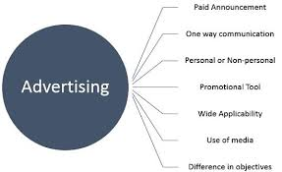

Figure 1 Advertising

## Brand Identity

Jasmine Fitness Club and Spa - Level 2 A modern fitness center with a nod to luxury and wellness. More than just a place to work out, the brand sells a total lifestyle experience with luxury gym equipment, spacious swimming pool, and sleek in-gym restaurant. It appeals to everyone from professionals, actors and athletes to families that wants performance and comfort while working out. Brand identity The brand is founded on the pillars of quality, community and wellness. That sensibility was brought to life in the commercial with warm lighting, stylish visuals and seamless camera work focusing on the elegance of the environment and its welcoming atmosphere. The ad modeled the tone of Jasmine—professional but welcoming—capturing the ethos of a space where health, wellness, and lifestyle converge fluidly.

(Essential Addons for Elementor, 2025)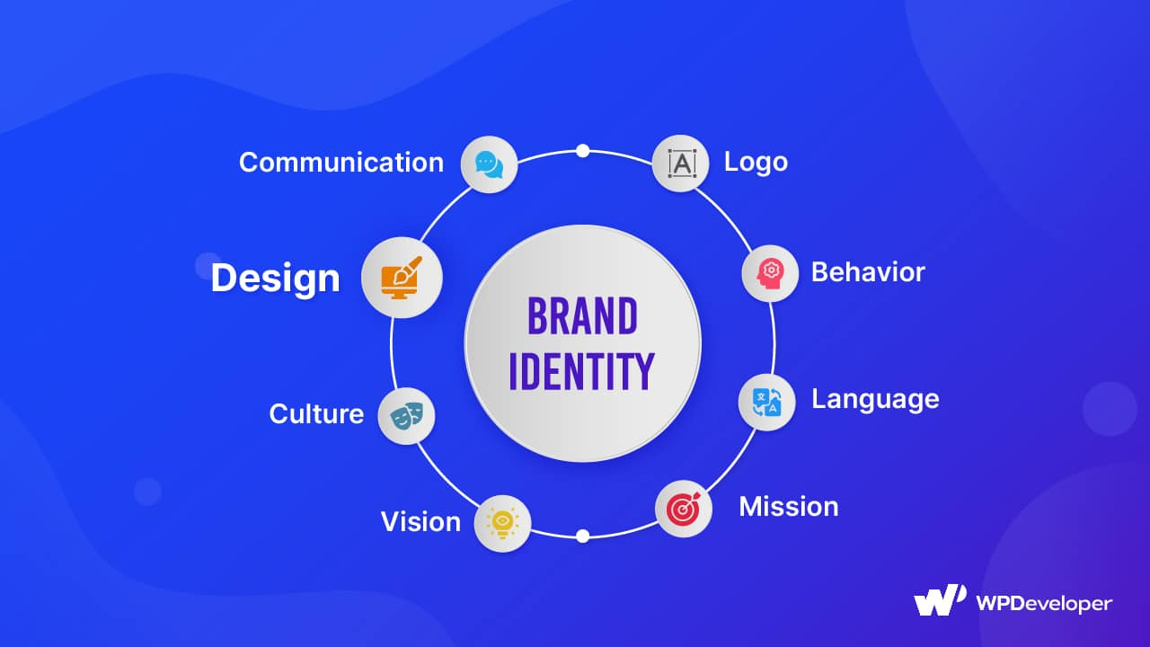

Figure 2 Brand Identity

## Techniques for Cinematic Shots

Cinematic sequences were also used to tell the visual story in the commercial. The environment was established with wide shots and tracking of subjects, pan and tilts as well as zooms added a little movement. Close-ups let us see emotion and detail, the over-the-shoulder techniques put us in the scene. Power and control were communicated to the audience by low and high angle shots. Slow-motion shots highlighted certain moments, and the bokeh effect separated subjects, resulting in an isolated look. Compositionally light direction, symmetry and leading lines were used to direct the viewers eyes and create the mood. These captures resulted in a sleek and professional ad that clearly defined the brand.

# Aims of Project

The project is an ideal sneak-beak of a professional television commercial (TVC) for Jasmine Fitness Club and Spa whose main objective is to demonstrate its top class quality of fitness service which offers an ultra-modern gym experience, surrounded with the pool of luxury and with the in-gym restaurant. We want Jasmine to become a total wellness concept, as a combination of a health, relaxation and lifestyle destination. ‘This ad will serve to not only advertise the company’s central ideals of luxury, community, and wellness, but also appeal to a broad target market that includes working professionals, athletes, thespians, and families.’ It is also a demonstration of how you can use digital media production skills, researched and scheduled through to cinematography and post production, to create a visually interesting production appealing designed to be viewed to industry standards.

# Software Used

## **Software**

Software is an instruction or program that the computer uses to perform tasks. It is the foundation for apps, games, and the little mundane bits of software that barely get talked about: anything that lets you write on a screen, or look at a web page, or make music, or draw or animate anything. While hardware is tangible, software is not — in the sense that it doesn’t exist in the same physical way that a computer does, but rather it exists to manipulate and manage digital operations. It is the backbone of every industry as it fosters efficiency, creativity, and interaction in the digital landscape.

### Adobe Illustrator

Adobe Illustrator is a vector graphics editor developed and marketed by Adobe Inc. Originally designed for the Apple Macintosh, development of Adobe Illustrator began in 1985. Because Illustrator is a vector-based program, you will not face a quality-loss tragedy when resizing. -Professional graphic designers and in printing industry it is commonly utilizing as precision tool for both quality and flexibility. -Ability to work in 3D, drawing makes it the number one choice for animated, logo scares and even It can use to design some maps.

I attached the illustrator file used in this Jasmine Fitness Club and Spa TVC to create Official Logo. The software allowed me to produce a clean, scalable vector logo with high resolution that is true to the brand. After approval of the final design, the logo was exported in a suitable file format and imported into Adobe After Effects for animation, guaranteeing seamless incorporation and preservation of quality throughout motion design and video production.

(Softonic, 2025)

Figure 3 Adobe Illustrator

### Adobe After Effects

Adobe After Effects is one commercial utility that comes to mind. It is commonly used for the post-production process of filmmaking and television production and acts as a tool for dynamic motion design. After Effects provides powerful features for compositing, keying, rotoscoping, particle systems, 2D and 3D puppet-based character animation, or tracking and stabilizing, and 2D and 3D integration of live action. It also integrates seamlessly with Adobe’s other products including Illustrator and Photoshop which is great for multimedia artists as well as video-makers among us.

I have done some animation with the logo I made on illustrator for Jasmine Fitness Club and Spa TVC using Adobe After Effects. Once the vector image was imported into my project, I animated the “headshot” using After Effects, giving the logo a professional level of movement to make the video more visually appealing. Animation brought a fun and branded aspect to the spot, and its use added life and pizazz to the commercial, resulting in a much more professional and fun commercial.

(Softonic, 2025)

Figure 4 Adobe After Effects

### Davinci Resolve

DaVinci Resolve is a professional video editing software. Its video editing and compositing feature integrate with a powerful suite of VFX and audio tools that are perfect for professionals who don’t have an unlimited budget. The software provides an all-in-one software tool for the filmmakers, film directors, professional editors and content creators. DaVinci Resolve With its robust timeline editing, real time effects, and exacting color grading tools, DaVinci Resolve will handle the duo's small and big projects.

I was the editor in charge for the final TVC of Jasmine Fitness Club and Spa in this project using DaVinci Resolve. Once I had finished animating in (redacted), I brought the rendered footage into Resolve and cut them in sequence, then added transitions as necessary. The sound was sourced as a download from a royalty-free website, and synchronized with the animation to improve the sound quality of the ad. Fine cut of the TVC was done in DaVinci Resolve, ensuring a painless and productive edit.

(Pinterest, 2025)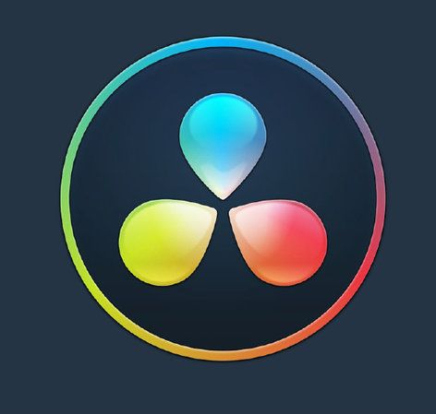

Figure 5 Davinci Resolve

## System Requirements

**ASUS TUF Gaming A15**

The ASUS TUF Gaming A15 laptop was used for editing and animation for this project. This machine has some decent specs when it comes to extra renders on programs like After Effects, and DaVinci Resolve. With its powerful GPU and multicore CPU, working was seamless when rendering 3D animations, video editing and motion graphics.

(Computer Planet, 2025)

Figure 6 Asus Tuff gaming Laptop

# Technology Employed

## Lightning Techniques

For the TVC shoot at Jasmine Fitness Club and Spa, we utilized continuous LED tube lights as our key light source. These lights were mounted high overhead and yet gave out a steady bright white light which seemed to fill the whole gym. This kind of lighting worked particularly well to generate a neat and professional atmosphere and the 4K camera was able to make sharp focus on the actors and the gym interior. The even light also stopped deep shadows that would obscure facial expressions and body language, a must for demonstrations of exercises and equipment.

The inclusion of LED tube lighting was also to help sustain the natural pleasing look and balance, that one experiences over the ambient lit conditions already found in the gym. Being positioned above eye level, it opened up for flesh skin tones and a pleasant light to shadow ratio, which would help boost the general look of the shots. Not only did this lighting style fit the mood and motivation one would need in a fitness commercial, it was essential to maintain a pro look that keeps the visuals looking snappy, clear and pretty throughout the wagon train of a shoot.

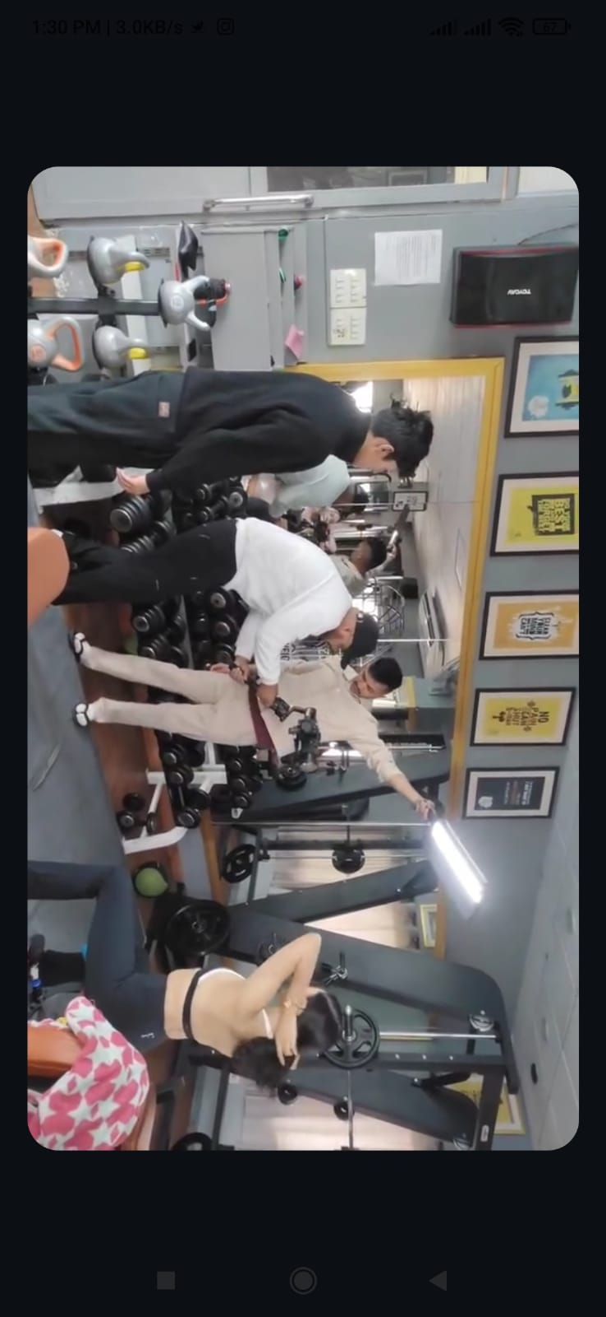

Figure 7 Lightning

# Editing Techniques

In the postproduction of the TVC of Jasmine Fitness Club and Spa, Scene binning and the sound cut rhythm will be handled with great care to ensure that the movie is a smooth and exciting piece. A major consideration of the editing was keeping the look uniform between various scenes in terms of color tone, lighting, and visual style. This was particularly significant as different shots were filmed under slightly different lighting circumstances or different camera angles. By doing some grading and adjusting the exposure levels in post-production I was able to establish a consistent visual progression, making the scene transitions feel natural and seamless.

I also did some beat cutting, where the visual transitions and scene changes of the VO were cut to the beat of the underlying track. This added tempo and energy to the TVC and made it significantly more kinetic and visually stimulating. By matching the strong actions and cuts to the beat, the end video immediately took on a slick and professional look which was in keeping with the high-octane health and fitness concept presented in the actual commercial.

# Mood Board

A mood board is a collage of visual images or words that is used in the initial stages of a project to help reflect the overarching design style and direction. It generally comprises an assortment of photographs, colours, textures, typefaces and other visual elements that set the mood and emotional response that will be the final piece. In this project, mood board was used to create strong visual starting point and was a guide for creative assets that involved lighting, color grade and also mood that reflects the style of the brand, Bar Jasmine Fitness Club and Spa. It was also a point of reference during the production to keep all the visuals consistent and inspiring.

# Resources Planning

## Budgeting

For this project, I made a very basic budget for to follow of what we needed and how much it would cost. Because this was a student project, much of the work was carried out with whatever was available, including personal laptops and free (or already-installed) software. Actors and locations didn’t cost extra money, so the project remained relatively low-cost.

|  |  |  |
| --- | --- | --- |
| **S. N** | **Items** | **Price** |
| 1 | Cinematographer | Rs 4000 |
| 2 | Assistant cinematographer | Rs 1500 |
| 3 | Camera and lenses (included in package) | Rs 10000 |
| 4 | Gimbal and Tripod | Rs 2500 |
| 5 | Lighting | Rs 3000 |
| 6 | Food Expenses | Rs 8000 |

# Schedule

## Gantt Chart

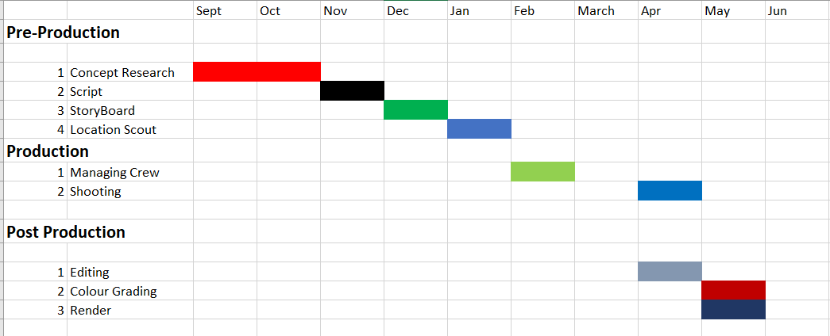

Figure 8 Gantt Chart

A Gantt chart is a project management tool that depicts the project as a sequence of tasks across time. It facilitates to plan, co-ordinate and track particular tasks in a project. That particular Gantt chart breaks down into three major phases: Pre-Production, Production, and then post-Production. Each phase consists of essential steps such as concept development, script writing, storyboarding, location scouting, team coordination, shooting, editing, colour grading, and rendering. The timeline shows each task with a colored horizontal bar, depicting the span of time from September to early May.

Pert chart One of the longest pats and highest proportions in pre - production going from path 1 to path 12 (Table 2) is the path of the Gantt chart from September through the end of February comprising all the planning tasks. The production stage was carried out in March and April, with an emphasis on crew management and filming. Post was done concurrently, with editing initiated in April, and colour grading and rendering lasting until early May.

## Pre-production Schedule

I came up with a pre-production schedule that will make everything done before the main production. That's from coming up with the idea, scripting, mood boarding and story boarding, visually mapping out how it'll come together, before doing all the software work on that. A realistic schedule also helped me to stay on point and deliver tasks in a timely manner, which contributed to this project running more smoothly. Once I got these details finalized, I was able to lock down the place where we shot: Jasmine Fitness Club and Spa along with the actor and the actress for the part. I also organized all of the tools, camera and lighting to be ready and worked out all of the timing and preparations with the videographer, so he will have a seamless, organized shoot.

## Production Schedule

Production for the TVC required the team to spend one full day of shooting at Jasmine Fitness Club and Spa. I shot all day various aspects of the gym including the entrance, a variety of workout areas, equipment, and interior design. The intention was to illustrate the gym’s modern and clean aesthetic, as well as its traditional fitness environment. There were camera angles and lighting that I planned to ensure the space looked appealing on screen. I uploaded the video to edit the same day, added the animations in the next few days. This easy flow of production was also how I was able to get all the footage I needed in one day.

## Post Production Schedule

During the post-production stage I concentrated on editing, compositing and finished the TVC. To start with I created the logo in Adobe Illustrator, before moving to animation in Adobe After Effects. The logo animation was featured on the intro and outro part of the video. Once animation had finished all animation was conformed in DaVinci Resolve for the main edit. In Resolve I pieced the clips together, fine-tuned timing, added some transitions and synced the background music I downloaded with the visuals. The software also permitted me to do some rudimentary colour grading and tweak the end product to maintain that professional gloss.

# Pre-production phase

## Concept Research

In pre-production I did a lot of conceptual research to come up with a strong concept for the TVC. I researched fitness ads, looked at branding for other gyms, and thought about how the visuals and messaging would resonate with our target audience. This study has helped me to find out about what tone, manner, and content Jasmine Fitness Club and Spa need to be represented in. I concentrated on showcasing its contemporary amenities, stylish look and feel, and irresistible vibe, but within a straightforward, motivating, on-point message that was true to the brand.

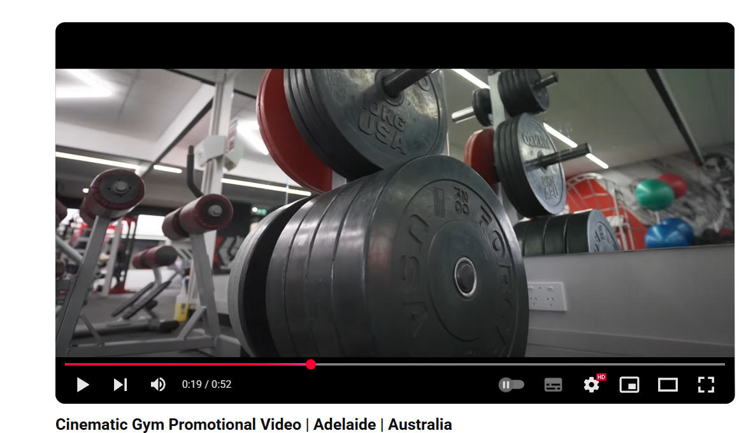

Figure 9 Reference Video 1

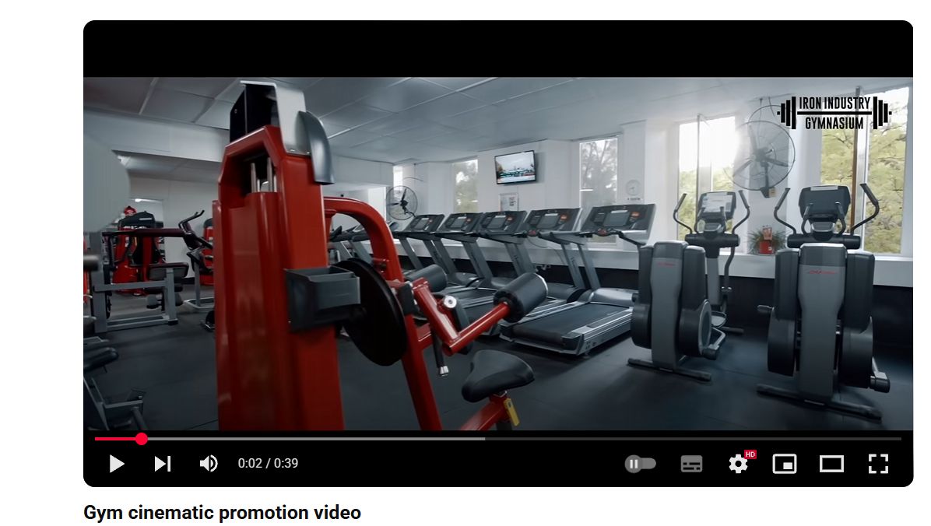

Figure 10 Reference Video 2

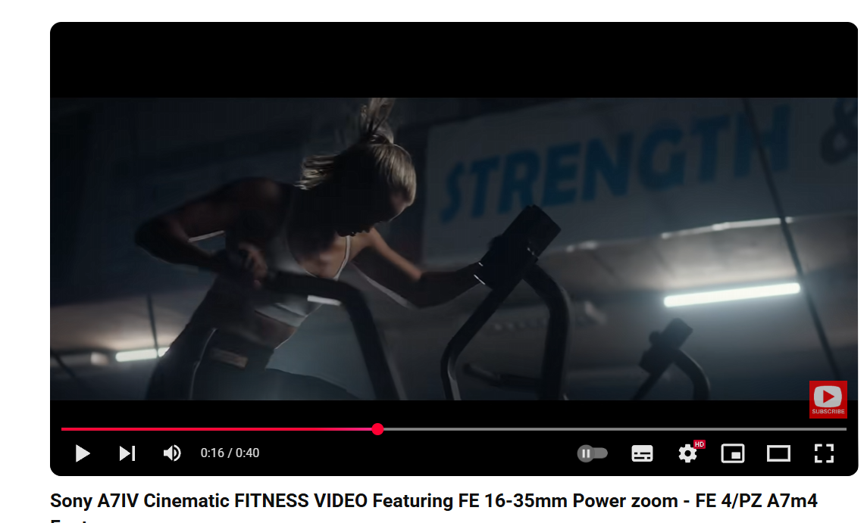

Figure 11 Reference Video 3

# Script

**Scene 1**

**Int. Gym – Close shot**

LOGO appears on the surface of the swimming pool.

**Scene 2**

**Int. Gym – Wide shot**

The interior of the gym is revealed with wide angles and cinematic imagery of space and modern design.

**Scene 3**

**Int. Gym – Medium / Close shot**

Fast rhythmic cuts expose workout machines in time to the music.

**Scene 4**

**Int. Gym – Wide shot**

Treadmill machines are lined up as though in motion with users, creating scale.

**Scene 5**

**Int. Gym – Medium shot**

Concentrate on weight plates and rod, ready to be lifted.

**Scene 6**

**Ext. Environment – Wide shot**

Establishing shot of the Swimming pool and the side of the adjoining restaurant.

**Scene 7**

**Int. Restaurant – Medium shot**

Ambient interior of the restaurant is shown.

**Scene 8**

**Int. Gym – Zoom out**

The camera zooms away from a workout machine, showing its structure and function.

**Scene 9**

**Int. Gym – Extreme Close shot**

Close-ups of weights and rope, emphasizing texture and grit.

**Scene 10**

**Int. Gym – Close shot**

A motivational quote mockup design is written on the board.

**Scene 11**

**Int. Gym – Medium shot**

A completed Dumbbell rack is shown, stacked up clean.

**Scene 12**

**Int. Gym – Close shot**

The actor prepares himself up for his workout, intense but calm.

**Scene 13**

**Int. Gym – Close shot**

Actor raises dumbbell and begins curling forcefully.

**Scene 14**

**Int. Gym – Medium shot**

A battle rope workout is performed by the actor; a dynamic camera shift.

**Scene 15**

**Int. Gym – Medium / Close shot**

The actress ready herself, tying her hair back, fixing her hair.

**Scene 16**

**Int. Gym – Wide shot**

The actress starts light exercise, doing pre-exercises.

**Scene 17**

**Int. Gym – Close shot**

Actor and actress sit next to each other, catching their breath for a moment.

**Scene 18**

**Int. Gym – Round Camera pan**

The actor performs skipping it is being viewed by a panning camera.

**Scene 19**

**Int. Gym – Close shot**

The actor switches to CrossFit workout, muscles flexed.

**Scene 20**

**Int. Gym – Close shot**

Pullups on angle; camera moves in dynamic motion.

**Scene 21**

**Int. Gym – Close shot**

Soon after we see actor -Athlete doing the deadlift.

**Scene 22**

**Int. Gym – Medium shot**

Actress doing Lat Pulldowns, muscles tight, concentrated and focused.

**Scene 23**

**Int. Gym – Close shot**

Actress performing Triceps Push Downs.

**Scene 24**

**Int. Gym – Close shot**

Actress is doing Overhead extension (controlling the movement).

**Scene 25**

**Int. Gym – Medium shot**

Actress performing cable rows, core and back are tensed.

**Scene 26**

**Int. Gym – Wide shot**

Actress on the treadmill, part of the Cardio segment.

**Scene 27**

**Int. Gym – Pan shot**

Actress is spotted cycling, in action camera pans.

# Storyboard

A storyboard is a visual representation of a video or film that outlines each scene or shot in sequence. It uses drawings or images along with brief descriptions to show camera angles, scene transitions, character movements, and important visual elements. For the Jasmine Fitness Club & Spa TVC, the storyboard helped plan each shot—from the logo reveal in the swimming pool to gym workouts and restaurant scenes—ensuring a smooth flow, effective timing with music, and consistency in visuals before filming began. It acted as a blueprint for the production team to visualize the final output.

## Scene 1

|  |  |  |
| --- | --- | --- |
| **Scene** 1 | **Shot:** Close Shot |  |
| **Location outdoor** |  |  |
| Figure 12 Scene 1 | | |

Description: LOGO in the swimming pool visible on the surface.

## Scene 2

|  |  |  |
| --- | --- | --- |
| **Scene** 2 | **Shot:** Wide shot |  |
| **Location Indoor** |  |  |
| Figure 13 Scene 2 | | |

Description: The camera goes wide, bathing the gym in with cine­matic images of space and moder­ni­ty.

## Scene 3

|  |  |  |
| --- | --- | --- |
| **Scene** 3 | **Shot:** Medium / Closeshot |  |
| **Location Indoor** |  |  |
| Figure 14 Scene 3 | | |

Description: Quick, rhythmic cuts reveal workout machines in synch with the music.

## Scene 4

|  |  |  |
| --- | --- | --- |
| **Scene** 4 | **Shot:** Wide shot |  |
| **Location Indoor** |  |  |
| Figure 15 Scene 4 | | |

Description: Treadmill machines are lined up, as if they are themselves in motion with users, establishing scale.

## Scene 5

|  |  |  |
| --- | --- | --- |
| **Scene** 5 | **Shot:** Mediumshot |  |
| **Location Indoor** |  |  |
| Figure 16 Scene 5 | | |

Description: Focus on weight plates and bar ready to be lifted.

## Scene 6

|  |  |  |
| --- | --- | --- |
| **Scene** 6 | **Shot:** Wide shot |  |
| **Location Indoor** |  |  |
| Figure 17 Scene 6 | | |

Description: Wide of Swimming pool on the side of the Restaurant next to it.

## Scene 7

|  |  |  |
| --- | --- | --- |
| **Scene** 7 | **Shot:** Medium shot |  |
| **Location Indoor** |  |  |
| Figure 18 Scene 7 | | |

Description: The interior of the restaurant is seen ambient style.

## Scene 8

|  |  |  |
| --- | --- | --- |
| **Scene** 8 | **Shot:**  zoom out |  |
| **Location Indoor** |  |  |
| Figure 19 Scene 8 | | |

Description: The work machine of an exercise machine is seen in a long shot from which the camera telegraphs.

## Scene 9

|  |  |  |
| --- | --- | --- |
| **Scene** 9 | **Shot:** Extreme Close Shot |  |
| **Location Indoor** |  |  |
| Figure 20 Scene 9 | | |

Description: Close-ups of weights and rope, focusing on texture and grit.

## Scene 10

|  |  |  |
| --- | --- | --- |
| **Scene** 10 | **Shot:** Close shot |  |
| **Location Indoor** |  |  |
| Figure 21 Scene 10 | | |

Description: A quote motivation mock-up is written on the board.

## Scene 11

|  |  |  |
| --- | --- | --- |
| **Scene** 11 | **Shot:** Medium shot |  |
| **Location Indoor** |  |  |
| Figure 22 Scene 11 | | |

Description: Above is a finished dumbbell rack, all cleaned up and in a stack.

## Scene 12

|  |  |  |
| --- | --- | --- |
| **Scene** 12 | **Shot:** Close shot |  |
| **Location Indoor** |  |  |
| Figure 23 Scene 12 | | |

Description: The actor readies for his vigorous, yet serene, workout.

## Scene 13

|  |  |  |
| --- | --- | --- |
| **Scene** 13 | **Shot:** Close shot |  |
| **Location Indoor** |  |  |
| Figure 24 Scene 13 | | |

Description: Actor lifts dumbbell and starts curling with all his might.

## Scene 14

|  |  |  |
| --- | --- | --- |
| **Scene** 14 | **Shot:** Mediumshot |  |
| **Location Indoor** |  |  |
| Figure 25 Scene 14 | | |

Description: The actor performs a battle rope in a dynamic camera cut.

## Scene 15

|  |  |  |
| --- | --- | --- |
| **Scene** 15 | **Shot:** Medium / Close shot |  |
| **Location Indoor** |  |  |
| Figure 26 Scene 15 | | |

Description: The actress prepares, pulling her hair back, fussing with her look.

## Scene 16

|  |  |  |
| --- | --- | --- |
| **Scene** 16 | **Shot:** Wide shot |  |
| **Location Indoor** |  |  |
| Figure 27 Scene 16 | | |

Description: The actress warms up with some light exercises.

## Scene 17

|  |  |  |
| --- | --- | --- |
| **Scene** 17 | **Shot:** Close shot |  |
| **Location Indoor** |  |  |
| Figure 28 Scene 17 | | |

Description: The actor and actress is side by side, both out of breath for a moment.

## Scene 18

|  |  |  |
| --- | --- | --- |
| **Scene** 18 | **Shot:** Round Camera Pan |  |
| **Location Indoor** |  |  |
| Figure 29 Scene 18 | | |

Description: A man is recorded ranging in age between adult and very elderly) skipping (he's shot with a rotating/panning camera).

## Scene 19

|  |  |  |
| --- | --- | --- |
| **Scene** 19 | **Shot:** Close Shot |  |
| **Location Indoor** |  |  |
| Figure 30 Scene 19 | | |

Description: A man is recorded ranging in age between adult and very elderly) skipping (he's shot with a rotating/panning camera).

## Scene 20

|  |  |  |
| --- | --- | --- |
| **Scene** 20 | **Shot:** Close Shot |  |
| **Location Indoor** |  |  |
| Figure 31 Scene 20 | | |

Description: Pull-ups with multiple views; movement feels strenuous and earthy.

## Scene 21

|  |  |  |
| --- | --- | --- |
| **Scene** 21 | **Shot:** Close Shot |  |
| **Location Indoor** |  |  |
| Figure 32 Scene 21 | | |

Description: focus and strength here.

## Scene 22

|  |  |  |
| --- | --- | --- |
| **Scene** 22 | **Shot:** Medium shot |  |
| **Location Indoor** |  |  |
| Figure 33 Scene 22 | | |

Description: Performing Lat Pulldowns too intently and without slack— “acting” the Lat Pulldown.

## Scene 23

|  |  |  |
| --- | --- | --- |
| **Scene** 23 | **Shot:** Close Shot |  |
| **Location Indoor** |  |  |
| Figure 34 Scene 23 | | |

Description: Actress doing Triceps Push Downs / Her Arms are Tightening.

## Scene 24

|  |  |  |
| --- | --- | --- |
| **Scene** 24 | **Shot:** Close Shot |  |
| **Location Indoor** |  |  |
| Figure 35 Scene 24 | | |

Description: Actress does an Overhead Extension - slow and in control.

## Scene 25

|  |  |  |
| --- | --- | --- |
| **Scene** 25 | **Shot:** Medium shot |  |
| **Location Indoor** |  |  |
| Figure 36 Scene 25 | | |

Description: Acting doing a Cable Row; shown are posture and core.

## Scene 26

|  |  |  |
| --- | --- | --- |
| **Scene** 26 | **Shot:** Wide shot |  |
| **Location Indoor** |  |  |
| Figure 37 Scene 26 | | |

Description: Treadmill machine actress steady state cardio wide space Actor running on treadmill at the gym doing steady Persistent Wide Space Visible.

## Scene 27

|  |  |  |
| --- | --- | --- |
| **Scene** 27 | **Shot:** Pan shot |  |
| **Location Indoor** |  |  |
| Figure 38 Scene 27 | | |

Description: Actress Cycling, Camera pans along with actress in smooth follow shot.

# Cast Selection

For the cast, I tried to pick a group of guys that would naturally represent the character of the Jasmine Fitness Club and Spa brand. A male and female was chosen for the job based on their healthy-looking image, comfortable on camera and that can represent the energy and lifestyle the gym tries to impart. Srichchha Pradhan, Miss Nepal World 2023, seen in the TVC. Actress powerful figure, a graceful, public figure known for her appearance and presence, and she made the video all the more impactful and credible. The cast performed to bring the visuals to life and connect them to the audience with realism, inspiration and passion.

# Location Scouting

The moment I saw the place when working on a location scout, Jasmine Fitness Club and Spa was sure to provide the right look and feel for my college TVC project. The gym’s contemporary interior, open space and aesthetics were exactly what I envisioned. The place charmed me and I went up to the management and offered to make a TVC (television commercial) for them as a part of my year end project. They said yes to a collaboration, which meant I didn´t have to sow my seeds on the carpet of a random apartment in the name of shots. This early part of the process informed the rest of the production, and resulted in a product that truly had an impact.

(Nepal, 2025)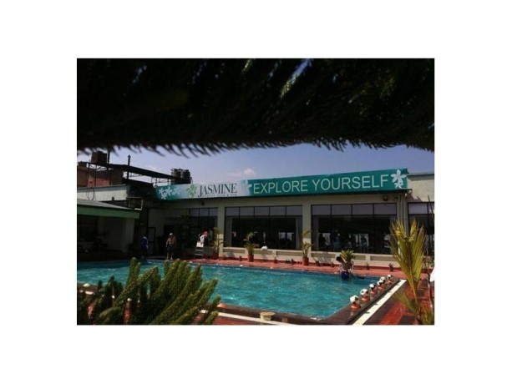

Figure 39 Location 1

(Justdial, 2025)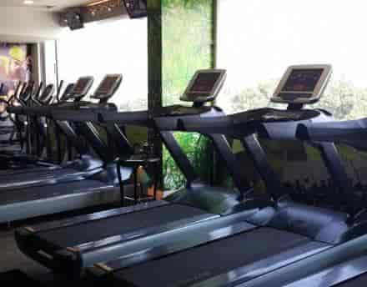

Figure 40 Indoor Location 1

(Justdial, 2025)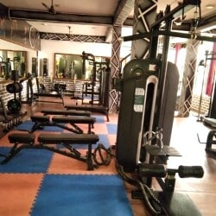

Figure 41 Indoor Location 2

# Production Phase

## Call Sheet

|  |  |  |  |  |  |
| --- | --- | --- | --- | --- | --- |
|  |  | **Jasmine Fitness Club & Spa TVC** |  |  |  |
|  |  |  |  |  |  |
| Director | Manish Yadav |  |  |  |  |
| Producer | Utsav Karki |  |  |  |  |
| Model | Srichchha Pradhan, Danish Bhatt |  |  |  |  |
| Lights man | Sujit Thapa |  |  |  |  |
| Cinematographer | Alok Budhathoki |  |  |  |  |
| Assistant cinematographer | Nawa raj Basnet |  |  |  |  |
| Editor | Manish Yadav |  |  |  |  |
| Music Composer | Manish Yadav |  |  |  |  |
|  |  |  |  |  |  |
|  |  |  |  |  |  |
| Crew Call Time | 10:00am |  | Shoot call Time | 11:00am |  |
|  |  |  |  |  |  |
| Venue | Jasmine Fitness |  |  |  |  |
| Weather | Sunny |  |  |  |  |
| End of the shoot estimated Time | 5:45pm |  |  |  |  |
|  |  |  |  |  |  |
|  |  |  |  |  |  |
|  |  |  |  |  |  |
| Cast | Role | Call Time | On set |  |  |
| Srichchha Pradhan & Danish Bhatt | Lead Model | 10:00am | 10:00am |  |  |
|  |  |  |  |  |  |
|  |  |  |  |  |  |

## Behind The Scenes

The behind-story series was a real insight into the work and teamwork that went into producing the TVC. From arranging the lights and camera angles to directing the actor and actress in each shot, everything had to be precisely choreographed. I worked hand in hand with the videographers to ensure the coverage went off without a hitch. Add to a mix of takes, tweaks and inspired flukes that challenged and amused along the way. Shooting clips and pictures behind the scenes to make a memorial of the effort, dedication and the experience learning from this college project.

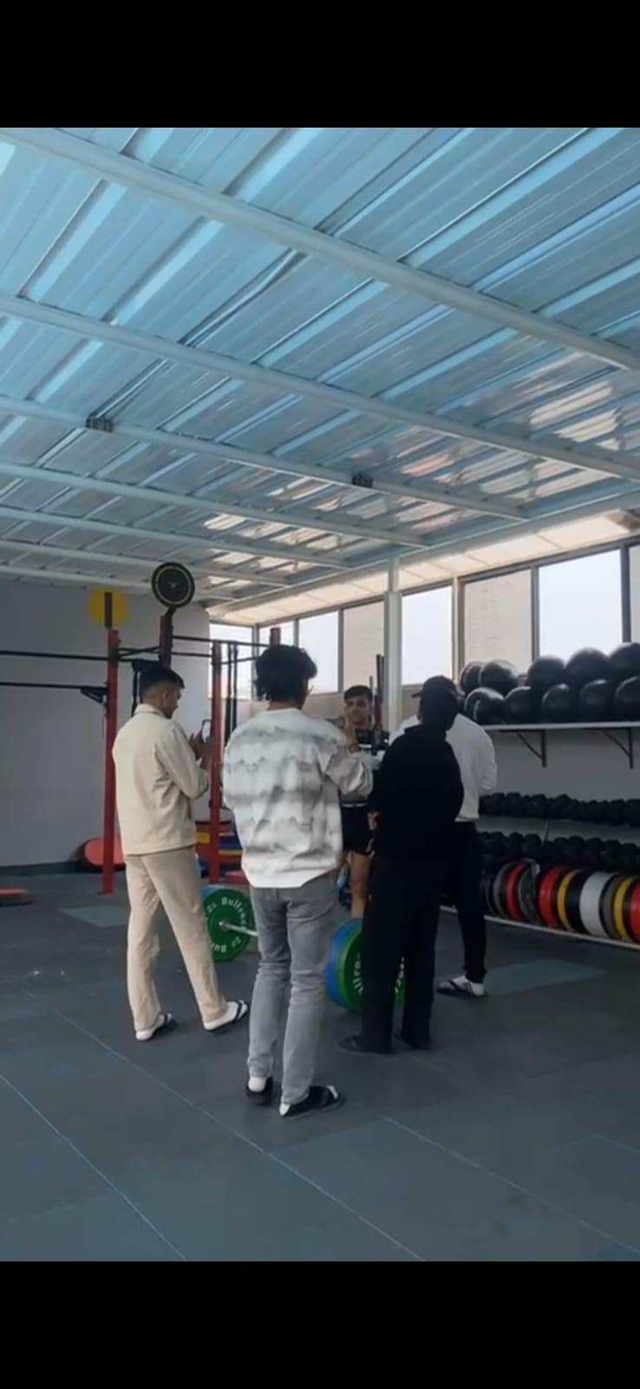

Figure 42 Behind the scene 1

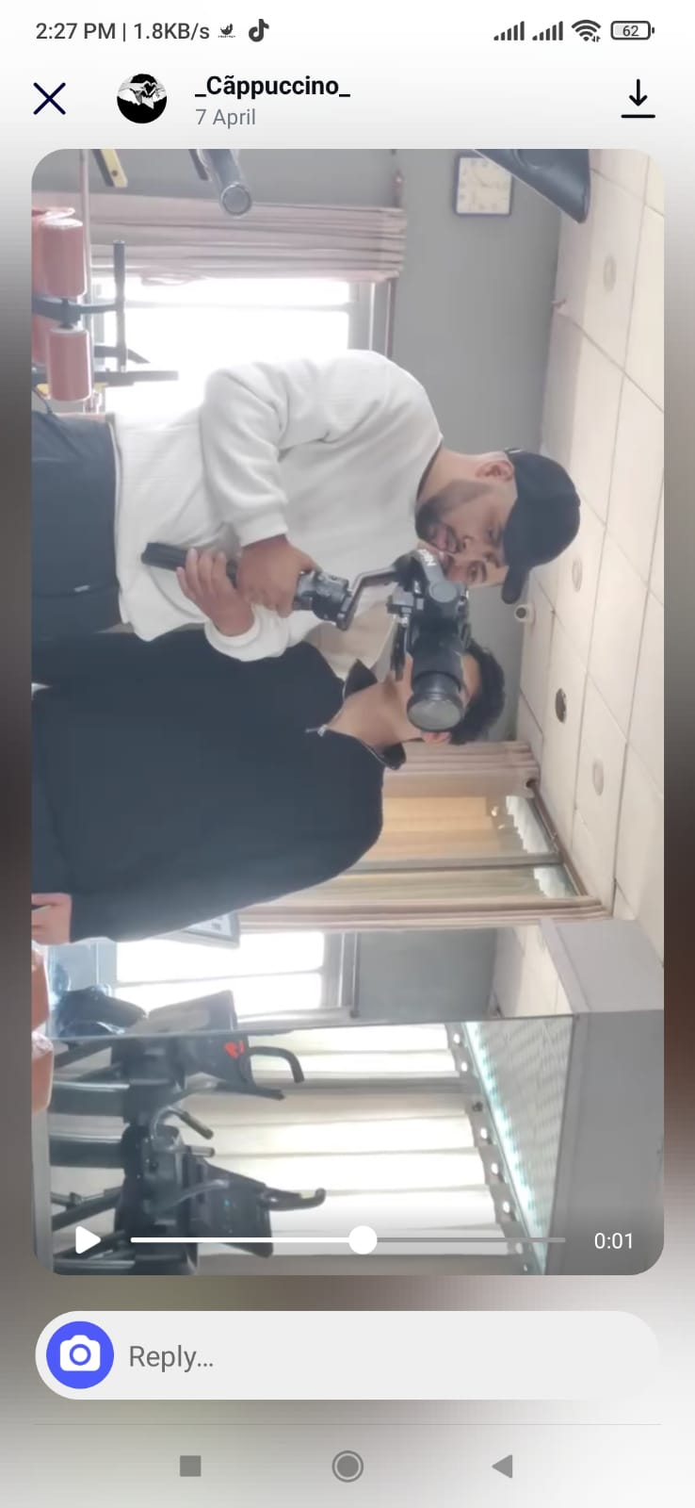

Figure 43 Behind the scene 2

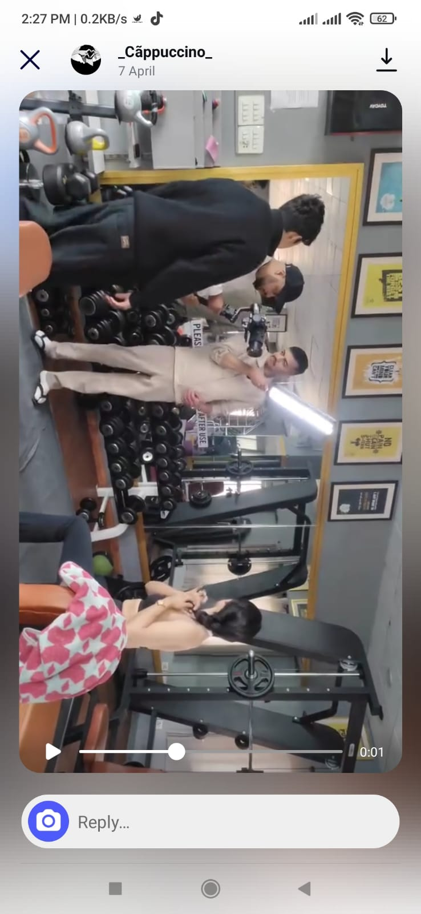

Figure 44 Behind the scene 3

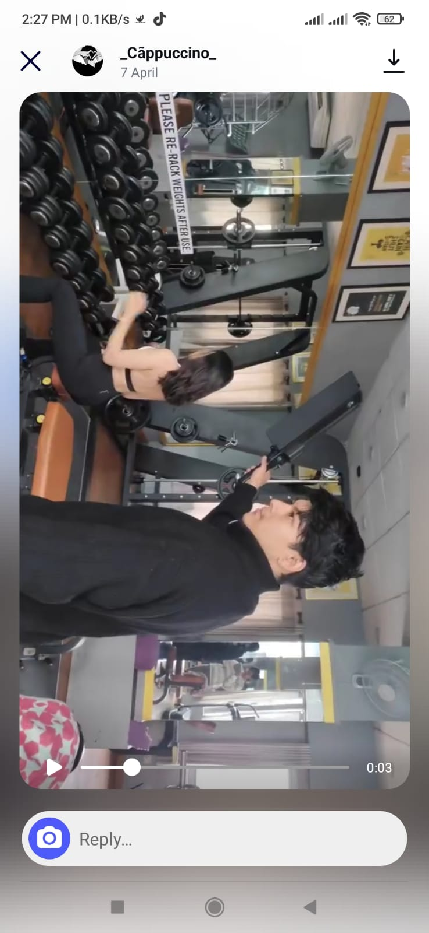

Figure 45 Behind the scene 4

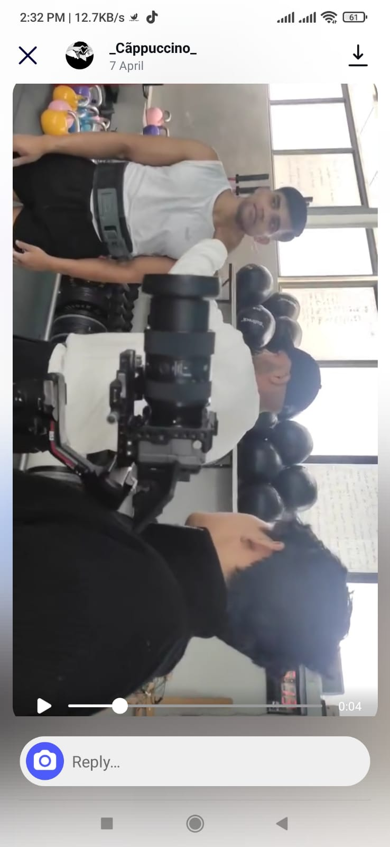

Figure 46 Behind the scene 5

# Post Production Phase

**Davinci**

The TVC project post production stage mainly used Davinci resolve as a software. I imported all the raw footage into DaVinci once the shoot at Jasmine Fitness Club and Spa was finished for editing. It was through that program that I stored the clips, cut and assembled them in sequences, put in transitions and matched the clips to the background music. One of the key highlights was its extensive Powerful Color Correction system which assisted me in changing the mood, and tone of the video to make it look more captivating/cinematic. With text overlays for context and consistent brightness, contrast and saturation settings for the scenes. Gates final edit was done in DaVinci’s smooth playback, live audio mixing capabilities and high-end export options added up to an efficient and pro session in the studio.

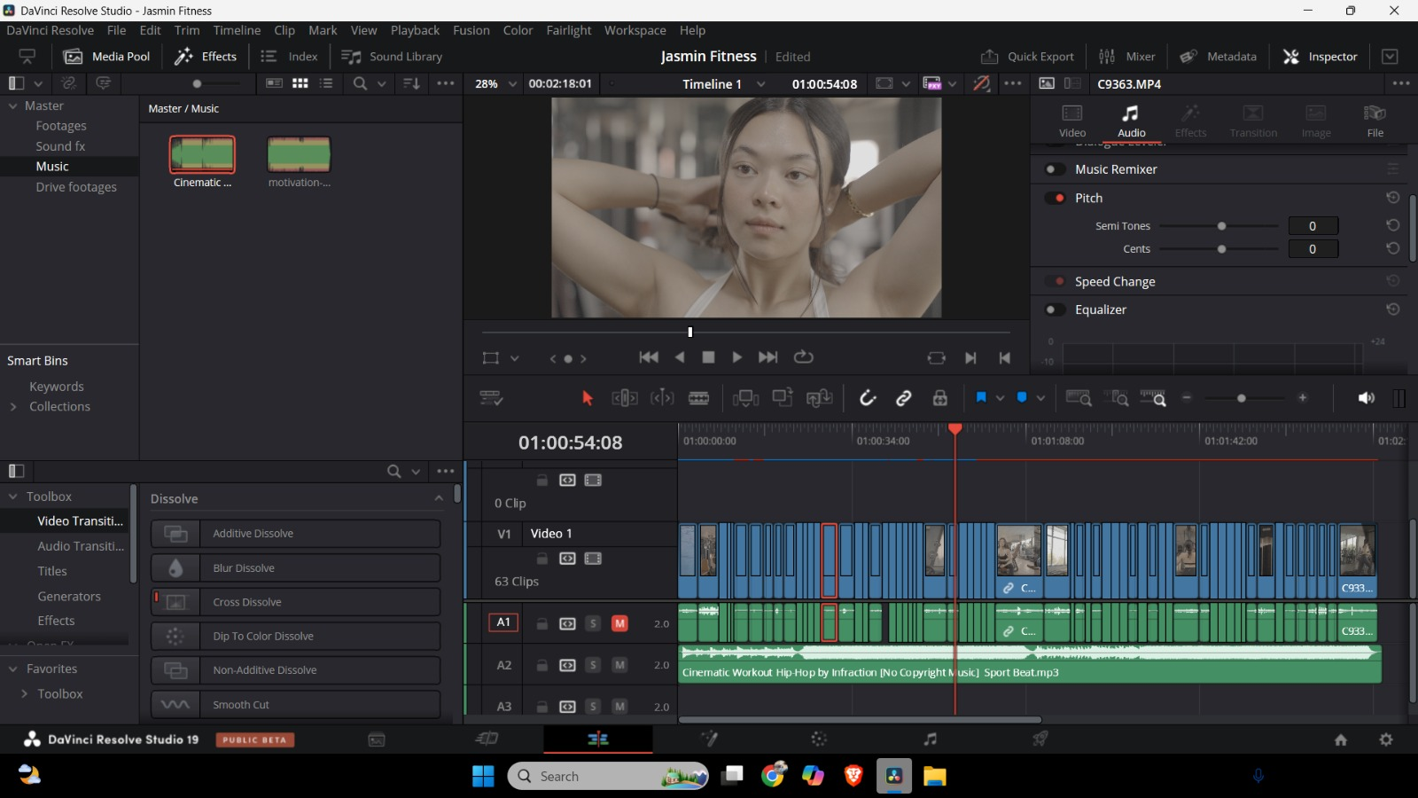

Figure 47 Compiling footages

**Colour Grading**

The visual appeal and mood of the TVC was significantly enhanced through color grading. Through Davinci Resolve's professional color grading tools, I delicately tuned the footage's brightness, contrast, and saturation in order to make the video look coherent and professional. I personally concentrated on the modern, sanitary look of the gym, making the shots look and feel fresh and professional. Through the use of shadows, midtones, and highlights I could evoke the types of mood I needed for each scene that would capture the luxury and vitality that Jasmine Fitness Club and Spa represents. The resulting video was of a cinematic quality, matching the brand’s profile perfectly and for the desired atmosphere to be delivered successfully.

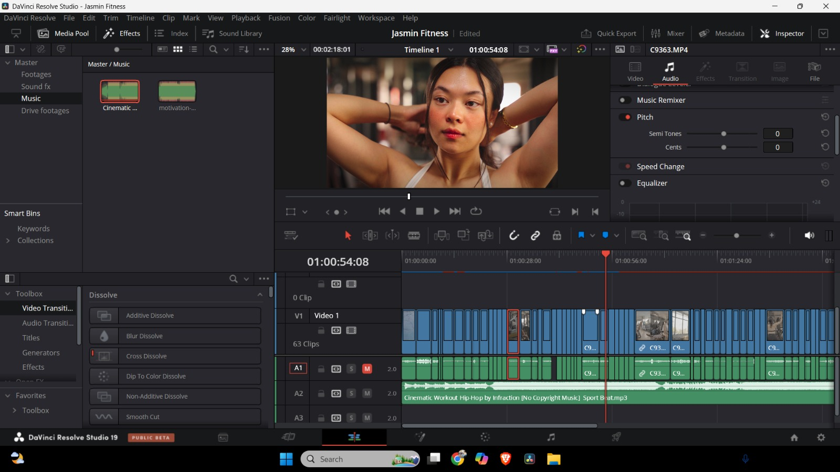

Figure 48 Colour grading

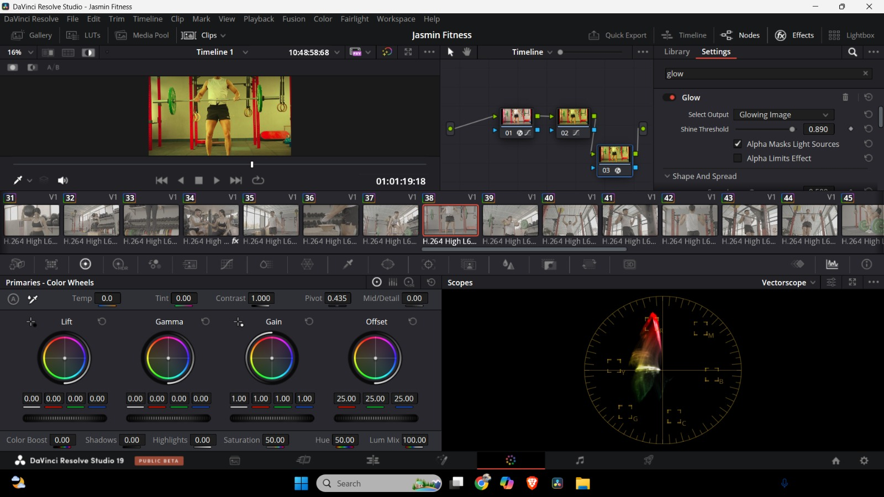

Figure 49 Adjusting Exposure

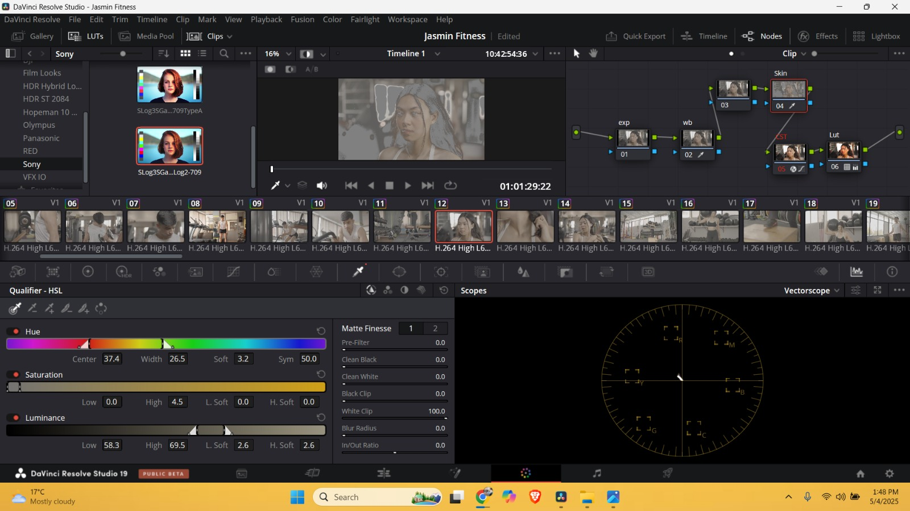

Figure 50 Colour grading

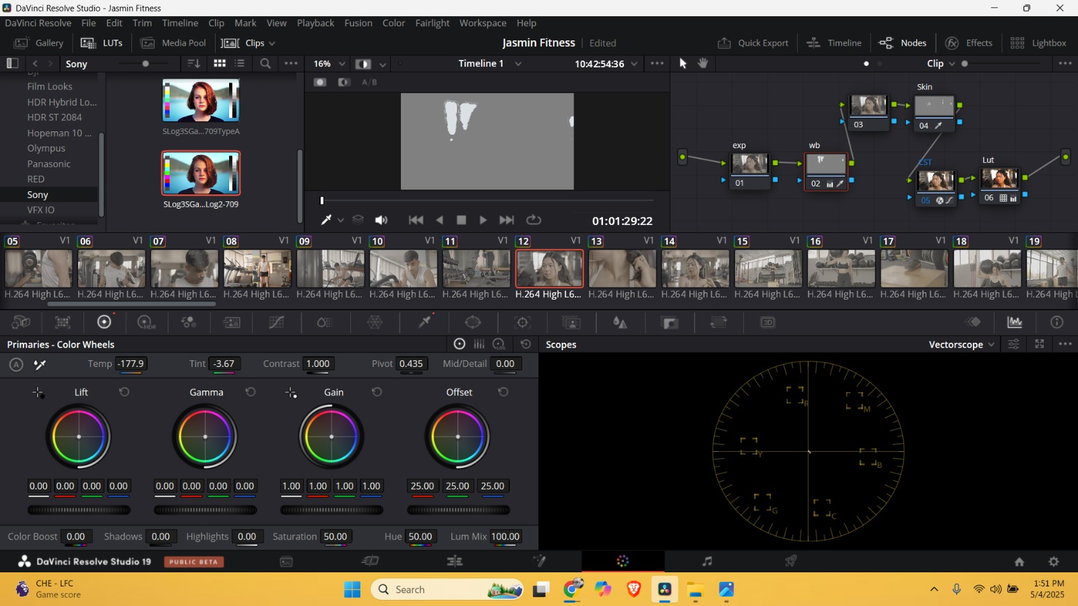

Figure 51 Adjusting skin tone

**Exporting & Final Output**

And at the end of the editing and color grading work, the project was ready for the “export and final delivery” phase, inside of the program DaVinci Resolve. Keeping the visual quality, but also the compatibility was crucial in this phase.

**Timeline Preparation:**

The whole timeline was watched down pre-export and a fine tuning was done to keep everyone on their toes to clipping, pace and synced audio. Both dynamic transitions, and motion graphics and color correction nodes were re-checked for flaws on rendering.

**Export Settings:**

To balance the high-quality vs performance consideration on supported platforms, the following settings were chosen:

File format: MP4 (H.264 codec) – The world wide web standard for online delivery.

Resolution: the resolution of the monitor is 1920x1080 (Full HD) as normal output.

Alternative Formats:

9:16 vertical version for Tok-tok and Instagram Reels

1:1 square size for use on Instagram feed

Frame Rate: 25Privileges25Privileges (to render on the same line of the custom project's timeline)

Bitrate: Determined for High Quality Graphics and to Maximize File Size

Audio: AAC, 48 kHz sample rate, stereo output – for clear sound recording wherever you and your phone may roam

**Render Process:**

With DaVinci’s highly efficient rendering pipeline the production of the different format versions (landscape, portrait) was possible in a time-saving way. In order to facilitate faster rendering and put less strain on system memory, Render Cache and Optimized Media were both on while editing.

**Final Checks:**

For each version, they tested on a variety of devices — phones, laptops and TVs — to ensure that the playback was stable, the audio matched and the aspect ratio was correct. Care was taken with the legibility of text overlays and the movement of the logo on varying screen sizes.

**Final Deliverables:**

Main TVC in widescreen (YouTube, Facebook, TV)

Social versions in 1:1 and 9:16 (for Instagram, Tok-tok)

File pack versions for sharing on mobile

Archival master in Pores (for all future high-quality releases)

# Problems and problem solving

## Cancellation of shoot

The Jasmine Fitness Club and Spa TVC was supposed to be shot on an earlier date but we were forced to postpone it. The model, Srichchha Pradhan (Miss Nepal World 2023) was out the country at the time of filming as she was representing her nation in the Miss World competition and was unable to take part in the shoot. This resulted in an 8-10 day setback. Also, there were protests in the nation at the same time, so it pushed back the shoot by 2 more days too. Even with these stumbling blocks, I was able to rework the production schedule to fit the model availability and get everything set for the shoot on the new day. This meant the project wasn't too delayed and the production quality could still be achieved.

# Resources

## Production Gears

* Sony Fx3
* Gimble
* Led light

## Post Production Gears

Asus Tuff Gaming a15

### Software

* Adobe Illustrator
* Adobe After Effects
* Davinci

# Evaluation of Cast and Team Members

The actor, actress, and supporting cast contributions were crucial in making this TVC project a success. Srichchha Pradhan, Miss Nepal World 2023, showed her professionalism and presented captivating screen presence that complemented the commercial. He also performed very relaxed and naturally so it also really reflected the message of the brand. I would also like to compliment the: videographer who let me use high-quality visuals, and was patient the whole time we were filming. And then also the friends that were a part of the setup, coordinating and every day on set having their help really helped to make the production run smoothly as well. Efficient and enjoyable process due to their teamwork, timing, and dedication.

# Third party evaluation

**Sandeep Shrestha**

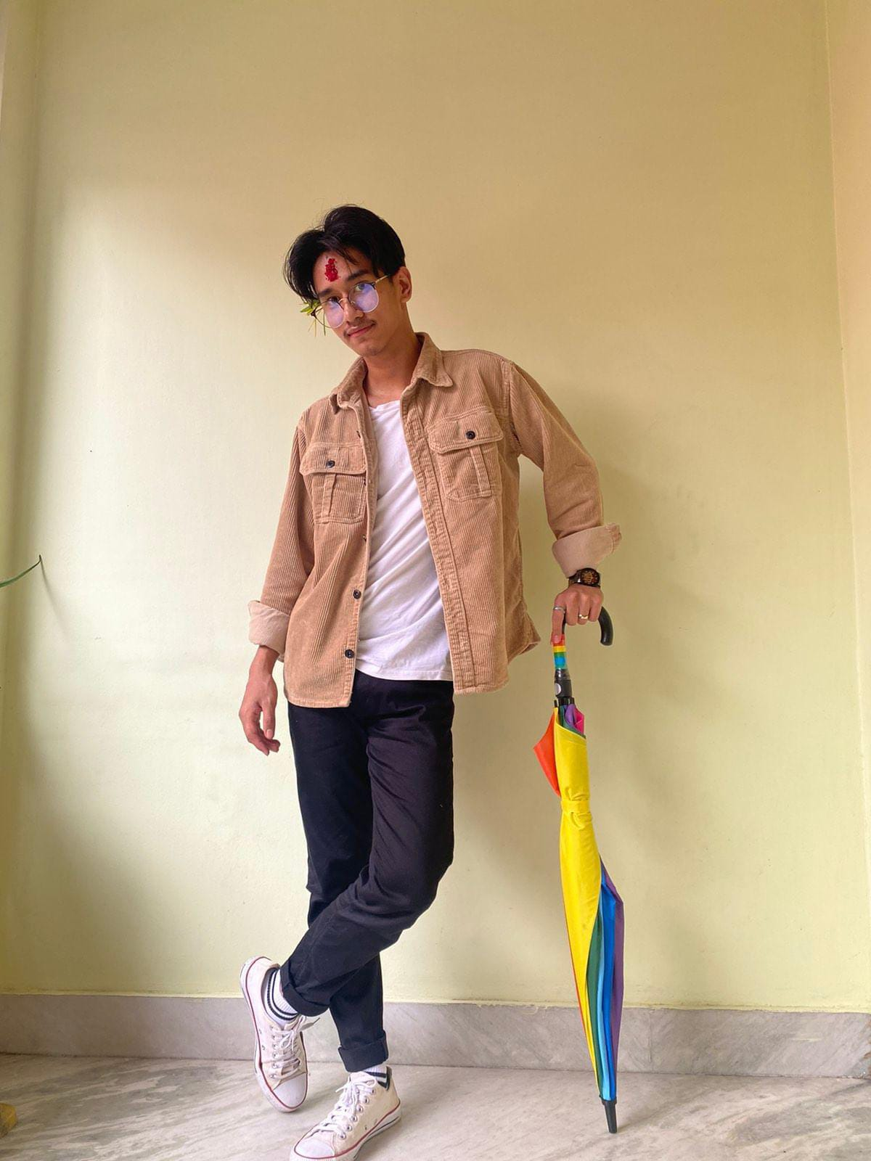

He was impressed by the technical polish of the finished video, particularly the strong camerawork and shots (which he might like better framed tighter). He noticed how everything had a reason for being and was well-composed, indicating a good grip on visual storytelling. Sandeep was especially taken with how the video’s rhythm mirrored the hustle of the gym, “The video kept me engaged throughout (from start to finish) the way it progressed and matched with the energy of a gym. He also praised the consistent nature of the tone and visual of the video.

**Sudikshit Thakuri**

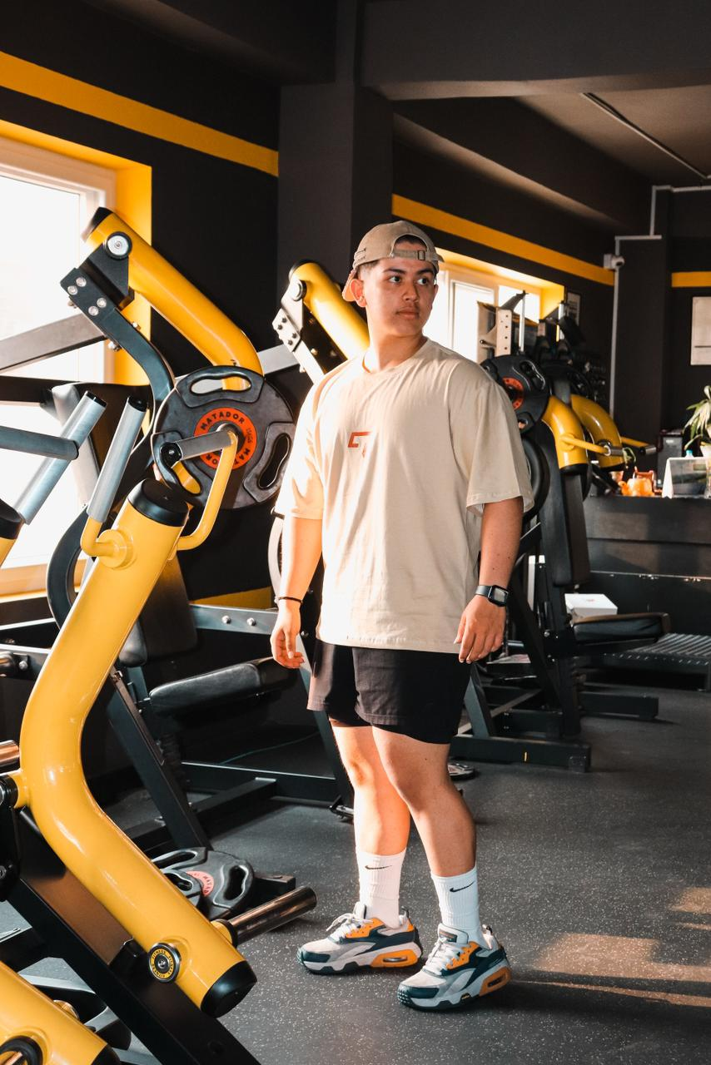

He especially liked the novel approach and overall look of the commercial. He commented that the transitions were smooth, the lighting was used well, and that the visual aesthetic was in line with the brand of Jasmine Fitness Club and Spa. Sudikshit made appearances from the cast performance and noted that their inclusion added realism to the gym environment. Mr. Surely thought the video was sharp, powerful and looked like a commercial for a professional fitness brand.

**Aayush Thapa**

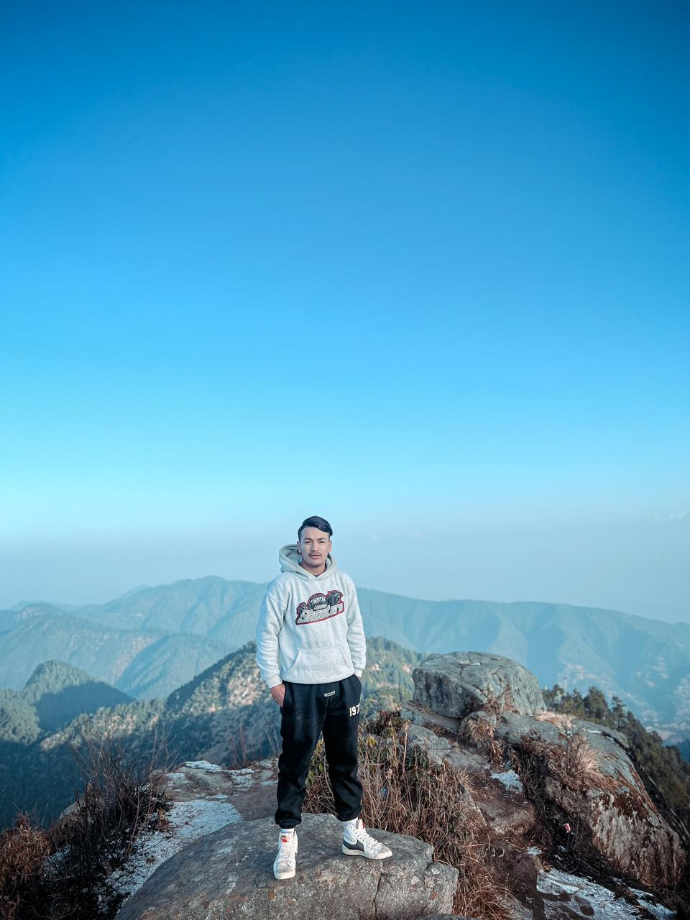

He called the work “serious next level.” He was amazed at how smoothly it all played from shot to shot, and how beautifully all the framing was, adding that if there was anything sloppy or unthought-through, he couldn’t find it. One thing that Aayush mentioned was how the output was very polished and clean. Specifically, he recalled how he was super-proud with how everything turned out and the well-received audience reception that did not just not feel forced, but made the video look and feel professional being such meticulous creativity that went into adding each and every detail.

# Conclusion

The process of making the TV advert for Jasmine Fitness Club and Spa as part of the SM6P07NI Digital Media Project module has been a fulfilling, all-encompassing creative experience. From the earliest development and research stages to production and post-production, this project is a hands-on learning experience in the planning, production and delivery of a professional media project. Securing your spot among high-end, community-based, wellness-minded, modern fitness practices, "Jasmine: Your Path to Fitness," other than an obvious fit of cinematic style jargon framing, distills the essence of the brand into a visually and emotionally impressive spot.

All of this was directly related to my knowledge of technical and creative skills (location planning, lighting set arrangements, camera framing, synchronization editing, visual effects and sound design). People I worked with – actors, a video camera person and feedback of the peers and advisor … it really shaped the final product. And in spite of tardiness hitches and any ad hoc problems that cropped up the work was finished on time and properly. It has all overall made me stronger in terms of my skills in media production and shown me to be ready to start producing professional client orientated content for the digital media industry.